TimeSprite

Status Reports and Project Submissions

Date: 16/10/2015 to 28/10/2015

University of the Pacific

COMP 188, Senior Project, 2015 Fall ---Yunpeng Zhang

Contents

2 Project Schedule 2

3 Currents Status 3

3.1 Finished Tasks 3

3.2 Falling being schedule 3

4 Plan for next work period 4

4.1 Task for next work period 4

5 Challenges and concerns 5

6 updated artifacts 6

# Project Schedule

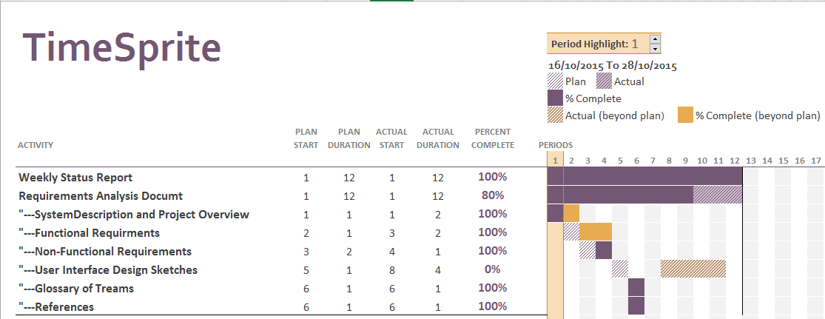

# Currents Status

## Finished Tasks

* Weekly Status Report
* System Description and Project Overview
* Functional Requirements
* Non-Functional Requirements
* Glossary of Terms
* References

## Falling being schedule

* User Interface Design Sketches

I plan use xCode to draw user interface at begin. But Swift does not have calendar view object for App. Therefore, it spent a lot of time to set up the third party library. I am still working on it. SO I did not finished interface Sketches.

# Plan for next work period

## Task for next work period

* Finish User interface
* Finish the document
* System design documents
* Set up the third party library

# Challenges and concerns

The swift does not have Apple Calendar view, so I will install plug-in called Pods. Pods can grab library from internet. It will support to create an Apple Calendar object.

# updated artifacts

Include:

* Requirements Analysis Documents
* Weekly Status report